6/15/23
Dear Allison and Susan,
Suggestions for meme:
Dear Blueprint Teams,
TARGET: July 4th BOOK LAUNCH
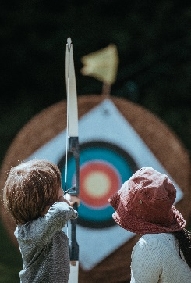
Aim: Outreach to Youth
Photo by Annie Spratt on Unsplash

TARGET: Change the World
Aim: For the Youth & ALL
Photo by Annie Spratt on Unsplash
I sent her a thank you already. She is on Twitter, so I thought it would be fun to send her the meme and a link to the BP. Maybe she will look at it and take original photos for the 31 categories. At least it might inspire her. The above image is copyright free. See Unsplash.com for details. Found it at: https://unsplash.com/s/photos/no-cost-archer-aiming-at-target She may have a collections page.
Photo/Credit location source pg: 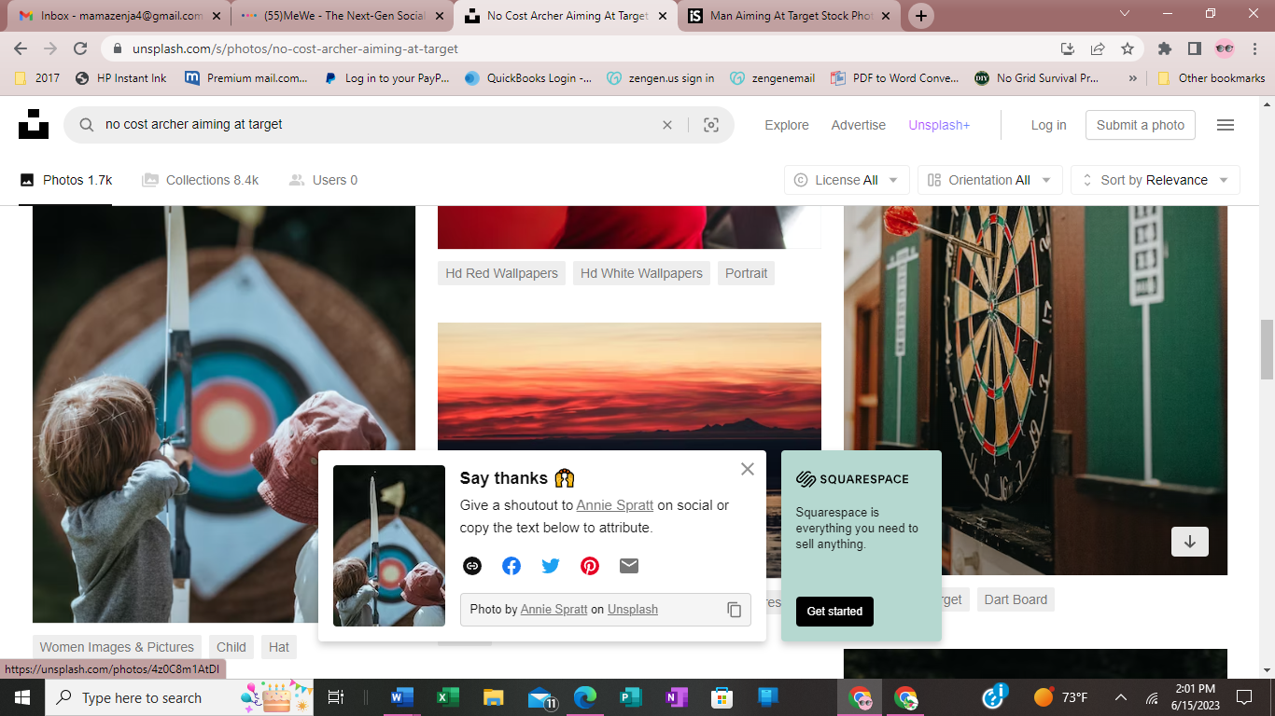
I will put together a mailer/flyer with the meme when it is posted.
MUSIC: I spoke with Zenja, he said the Book, Social Media, & Website Teams have carte blanche to snag whatever music they need from his zenjaverse:
https://www.youtube.com/@zenjaverse3895 I tried to find my list of the videos and their topics, but it is from 2018.
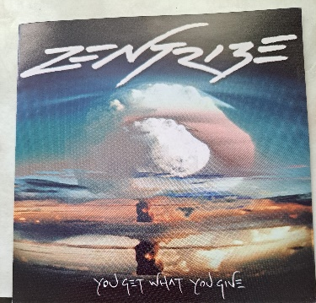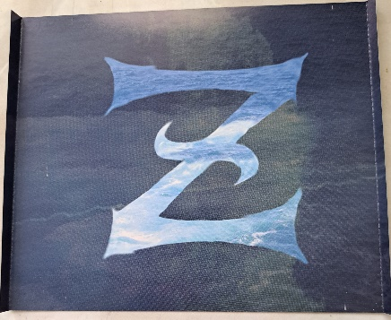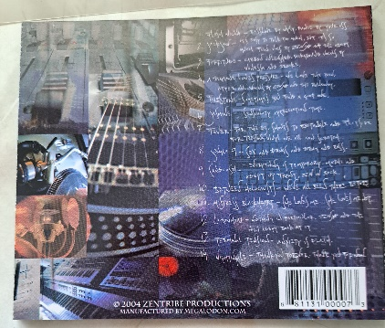
I forgot to ask him about any spotify account. I will put uploading some of his CDs onto a thumbdrive on my project list asap to be able to send to you as he helps me determine their best use.
The drum builder son is rafting the river for 4 days. I will talk to him about recording a variety of hand drumming drum music when he returns. You will hear some of it on the CD above. Zenja led the pack and got his other 3 brothers to contribute some of the vocal, lyrical, instrumental content. They will be fine with the same no copyright use for your needs.
Hugs,
Deb / Mama Z

