MIDGARD
For the greatest and highest good:
Midgard and Solar System
The outer sun is restored to full natural capacity.
Solar-system planets are maintained in optimal orbits in relation to each other and for the benefit of their inhabitants if any.
Midgard axis is restored to natural orientation, restoring correct equator and positions of land masses and oceans, and restoring climate.
The inner sun of Midgard is shifted to the planet's center, operates at appropriate capacity, and is fully and appropriately shielded.
The planetary rotation on its axis is now clockwise, so the sun comes up in the west each day.
Every day is equinox because of zero degrees tilt of the axis.
Natural moon is restored to orbit around Midgard.
Option: Two more natural moons are put into orbit around Midgard, the three having orbital cycles of 30, 40, and 60 days, or as required for energy balance.
Midgard's Ancient Former Moon Periods:
Layla - 13 days
Fatta - 7 days
Mesyac - 29/30 days
(origin of week, fortnight & month time periods that we still use)
With these periods, the 3 moons would have aligned in
the sky every 90 days (origin of quarter-year time period)
Oxygen and carbon dioxide levels are high and beneficial for all Midgard life forms.
The waters of Midgard are clean, healthy, coherent living H₂0₂He₃ waters beneficial to all Midgard life forms.
The salts tainting the seas are precipitating out and collecting in easily mined coastal areas around the world. This process is gradual, allowing ocean life to adapt to fresh-water conditions and allowing land-based life in the coastal areas to adapt to the higher salt levels.
The ancient forests of huge trees are growing again.
Organic-silica-based life (if this applies to the ancient forests) and organic life are thriving together in symbiosis.
As in ancient times, a wide variety of tasty and edible fruits, nuts, seeds, leaves, flowers, root-vegetables and tubers are abundant year-round and are easy to access.

For the greatest and highest good:
Humanity and Midgard
HUman time operates the same all year, with midnight being the time of lowest energy and noon being the time of highest energy. Time zones are maintained to facilitate communication.
The global media are now under the control of the people and are revealing true history, true science, and true events.
Dachas, whether as weekend retreats or as permanent homes, are proliferating under true Rule of Law, Universal/Rta Law, and land-tax systems that encourage independence, self-sufficiency, home title (Allodial Title with right to bequeath the title), and creativity. Farms are held under special Farm Title that encourages family or cooperative-group small farming and organic and natural food production methods, but is not available to corporations or other organizations.
Companies operate under the Cooperative Business model. Companies are local, with local employees, local suppliers, and local clients. All people, communities, and regions strive for the highest degree of self-sufficiency possible.
Industrial activities that by their nature operate beyond the local level are under the oversight of all of the communities in which they operate.
Administration of utilities and services such as roads and communications equipment beyond the local level is operated by councils that have only administrative responsibilities and authorities and operate under the oversight of all of the communities within the region of operation.
Legislative authority remains at the local level―whether village, town, or city―and the size of a community has no bearing on its authority within a region, whether that community is represented at a township, county, state/province, country, continental, or global conference.
All forms of media disseminate truth, by law. All forms of media promote beneficial ideas and systems for the benefit of the all.
Schooling, including homeschooling, benefits the children and teaches useful skills and knowledge, critical thinking, social harmony, spiritual innerstanding, positive self-worth, and independence. Children are safe, cared for, and loved.
Men and women respect, trust, and value each other and interact in harmonious ways.
Communities are safe environments where inhabitants work together to ensure all have their basic needs met, where justice is accomplished through true Rule of Law, where Universal/Rta Law is known and comprehended and honored, and where the people protect and value each other.
Health care actually promotes health and is available to all.
Food is healthful and available to all.
Large-scale exchange systems such as those between continents are based on barter of goods and/or services. Local exchange systems are based on barter of goods and/or services and/or on monetary systems that may include local currencies accepted by communities throughout regions. (See also “Brave New World” file)
The Trust ensures global access to secure communications and fair distribution of resources.
Basic needs for individuals includes: safety and security; clean water; high-quality nourishing food; adequate shelter and clothing appropriate to the climate and terrain; adequate energy for heating, cooking, cleanliness, technological needs such as communications; suitable sanitation; communications, especially for emergency services; transportation, at least within the local area; emergency health care if required; means of learning needed skills and knowledge.
Basic needs for communities includes: sanitation; clean water and means to distribute it; means of food production; means to provide shelter and clothing; means to provide energy; communications infrastructure; tool manufacture; adequately trained and emotionally stable teachers; adequately trained and truly caring healthcare providers; means for pleasurable social interaction among members of the community, including and not limited to dances, fairs, cookouts, etc.; means for inhabitants to govern the community fairly and provide for the needs of all; means to communicate with other individuals, groups, communities, regions, etc; a stable tax and exchange system that is fair for all; emergency services including health care, sheriff department, fire department, and court, and possibly a people's militia that can be part of a wider planetary defense.
Safety and Security:
All members of each community learn Rta/Universal law and True Rule of Law, including how to launch claims, and also learn how to send various types of distress signals.
In larger communities, neighbourhood groups establish a watch force trained by those with skills in: First Aid; detecting and first response to fire; detecting and first response to domestic abuse and other threats to individuals; flood control; search and rescue; and de-escalation of conflict. Such groups operate on a cooperative basis with all members as leaders and with appropriate and fair scheduling of active duty OR (preferably or eventually) on a casual basis with all inhabitants trained and simply looking out for each other.
The Sheriff Department, and People's Militia if any, are accountable to all the inhabitants of the community―as a collective and through the local court and council, as appropriate to any given situation―and not to outside groups or organizations, nor to local family or other interest groups with purposes and intentions not for the benefit of the all. Further, all members of a People's Militia, court, and Sheriff's Department, as well as all members of a local council, are required by law to: live in the community in which they serve and make oath of office to serve the community.
When personnel of the People's Militia, Sheriff Department, court, or community council need to engage with corresponding organizations outside the community, all involved in the issue (whatever it may be) are of equal authority and equally responsible to and for the members of their own community and the wider region.

Possible Oath of Office, which can be modified for specific application, and which is spoken aloud before the corresponding document is signed, both actions taken before witnesses and the document then filed in a local Records Office:
General Oath of Office
I, ___________________________________________, a sovereign being of sound mind and clear conscience, do hereby swear that I will faithfully and justly execute the office of ___________________________________________ and I will uphold the rights and wellbeing of the people of the community, the Universal Law, Universal Principles, Rule of Law, Fundamental Liberty, and the Foundation legislation and ordinances of the Sovereign Community of ____________________________________________ according to the best of my abilities.
I understand that if I fail in my duties or if I betray the responsibilities and trust of my office I forfeit my right to this position and face dismissal and possible legal action.
I take this solemn oath freely, without coercion, reservation or ulterior motive, according to my conscience as a sovereign (man or woman), and as a flesh and blood (man or woman) living under the authority and jurisdiction of the Universal Law.
Autograph: ___________________________________________________
Witness: _____________________________________________________
Witness: _____________________________________________________
Witness: _____________________________________________________
Date: ________________________________________________________

Governance:
The local community Council/Congress/Parliament meetings are open to all members of the community, and all inhabitants are notified of the date, time, and location of such meetings. Results of meetings are posted for all inhabitants to review.
Committees may be formed to address specific issues or needs, and standing committees deal with the overall administration of the community.
No position on Council or Committee is permanent. Many or all may not be paid, although any necessary and justifiable out-of-pocket expenses are reimbursed. Positions are filled through general elections or jury-style selections, with an individual's experience and knowledge affecting subsequent placement, and all who take such positions must make Oath of Office and are subject to dismissal for any misconduct.
The Sheriff Department, People's Militia if any, Court, Treasury, Auditor, and banks are subject to oversight by the community Council and the inhabitants of the community.
All lands, waters, and other resources within the boundaries of the community are under collective ownership by and oversight of the community and its Council, with due acknowledgment to The Trust as Guardian of all Midgard Earth assets and to the collective ownership of all assets by the populace of the planet as a whole. Jurisdiction may be shared among regional communities, especially for remote areas or shared watersheds.
The local community Council, through a standing committee for Lands and Resources and through the local Treasury, ensure that all inhabitants have a home. A Dacha system may be arranged and/or a system whereby homes and lands that are abandoned (through whatever means) may be transferred to another individual or family, or given over for a particular use, or placed into a reserve for eventual amalgamation of small plots into larger ones adequate for a dacha or similar homestead use.
More Governance Ideas
Instead of elections, which attract narcissists and other opportunists, a lottery-in and vote-out system can be implemented in which members of the community eligible by age and otherwise not disqualified under law are selected by lottery to serve for a specific period and can be voted out (impeached) for misconduct such as violating their oath of office.
Once selected, they sort themselves into specific offices or committees according to their knowledge and abilities and possibly their willingness to learn.
Communities operate on a primary set of Universal laws not subject to amendment or abolition. They can then make additional laws, as required, that do not violate the principal laws. Local governance is mainly concerned with accomplishing tasks and projects and general oversight of the community, and does not require a “law” for every activity.
Administration is carried out at the local level by the governing council under the oversight of the community members, who can use the vote-out or the local court to address grievances serious enough to impact the members of the council.
Administrative bodies at successively broader levels (county/region, province/state, country, and beyond) have no authority to make laws, only to administer rules and activities agreed by and under the oversight of the communities within their area of operation. That may seem unwieldy, at first, but should sort itself out quickly, with rules established primarily on custom and/or what makes sense for the particular activity, and aligned with Universal Law.
For example, most traffic safety rules would remain in place, but licensing would no longer be a corporate or legal matter. Identification of vehicles and drivers would be under local jurisdiction as a matter of safety (such as being able to identify vehicles and persons involved in an accident) and ensuring drivers actually know how to drive).
The majority of existing regulations would disappear because they have been put in place merely as control mechanisms and to siphon money from the people. The basic laws accepted across regions and countries would provide the grounding from which to operate in a sensible and adult fashion. And Universal Law courts would catch whatever might otherwise fall through the cracks.

Day-To-Day Life:
People live in their own home on their own land (under Title) or in a rental unit managed by someone else from the community. Title holders pay the Land Value Tax. Renters pay their share of the Land Value Tax, apportioned among the renters and the nominal "owner" of the land if that is not the renters as a collective. (Renters may hold Title cooperatively and contract out the maintenance of the property.)
People and businesses may choose to contribute to a Community Health Assurance Fund and other community-enhancement programs.
People take part in the community through: learning Universal Law and True Rule of Law, as well as their rights and liberties; taking part in governance, if only through attending meetings and making suggestions or alerting the Council to needs; joining others to safeguard their neighbourhood or the community as a whole; learning skills such as First Aid and participating in communal Emergency Preparedness Exercises; taking part in community activities such as dances, street parties, fairs, etc.; and learn new skills toward self-sufficiency on the individual and group level. Knowing one's neighbours is encouraged and facilitated.
Inhabitants are encouraged to grow their own food to whatever extent they are able and to share seeds and seedlings and livestock; harvest rainwater and snow melt; compost; use alternatives to old sewage systems where feasible; and otherwise become as self-sufficient as possible.
Schools and homeschooling programs include life skills, arts, true history, true law, and community and social engagement. Programs include interaction between elders and children, and may include family and/or community celebrations of life events such as birth, naming, transition to adulthood, approaching end of life, and more.
Techniques of spiritual healing and growth are available to adults as well as children, along with actual physical-healing methods.
Communities are developing their own arts and fashions. Local people are making their own tools, such as brass or copper garden implements and other items previously difficult to find or expensive to buy.
Communities and regions are developing a local economy based on self-sufficiency and sharing rather than merely direct exchange, just as families provide for each other without compensation or exchange equivalence.
Food and feed plants are thriving everywhere, including ancient varieties that are both healthful and delicious. Bees and other beneficial insects as well as birds and other animals benefit ecosystems everywhere.
People are healthy, relaxed, creative, fulfilled, and are devoting time to their spiritual growth. Communities are places of fun and creativity, family and safety, and harmonious interaction.
Men and women recognize and value their own and each other's strengths and attributes and capabilities. Men and women recognize members of their own genetic race, whether consciously or subconsciously, and naturally mate with members of their own genetic race.
Children are valued, safeguarded, and nurtured as the Crowns of Creation and manifestation of the future that they are.

Time Management
The new "old" calendar would soon take off when people find it better than the current one, designed to harvest our energy through the constant stress of the Gregorian Calendar. It's in the meaning of "calendar": a 16th C word from Latin "calends," from the Greek "kalos," meaning "to burn, kindle, sacrifice by fire" and "endios," meaning "to be." So calendar literally means "to be sacrificed by fire." Therefore, the Gregorian Calendar makes each day a sacrifice to Ba'al, Moloch, Satan by fire. Kind of feels like that as they harvest our energy through this constant race against time. “Time is money” in their world, so we tread the hamster wheel, trading life force for paper and trinkets to survive... exhausting.
The previous word was "almanac" from Latin "alma," meaning "kind or fair," and "nactus," meaning "to obtain or reckon, to estimate or find." So almanac means "a system of fair reckoning and estimation of time and celestial movements," an organic model based on the natural movements and rhythms of the universe, putting us in tune, in resonance with natural rhythms.
So the question is not why would we change, the question is why wouldn't we change to something that enhances life rather than harvests our energy. Humanity benefits when we make synchronicity with nature and planet restoration activities the central focus and accomplishments that folks derive pride from.
OPTION1: 6-DAY WEEK, 5-WEEK PER MONTH ALMANAC
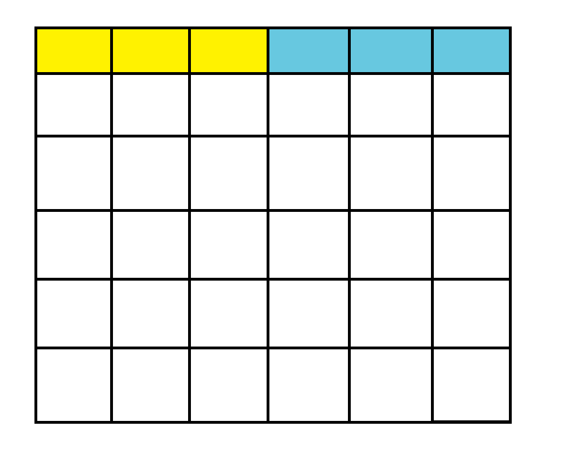
Note: People can choose for themselves a four-day work week and two-day weekend instead of the standard three days on and three days off. Work-week start day can be staggered for different organizations, employees, etc.
This system has the advantage of easy scheduling of workers in any company.
6 days per week, 5 weeks per month, 60 weeks per year would allow everyone a three-day work week and a three-day weekend, thus ensuring all businesses and services operate continually and employment is high. Shifting the start of each work week for some people provides overlapping supervision and/or other activities as required for any given business or service. The long weekend allows time for dacha or other type of gardening, family connection, spiritual pursuits, and community activities.
The year can be divided into thirds (20 weeks each) or quarters (15 weeks each), as deemed appropriate for any particular purpose.

INTERIM
Until the 360-day orbit is achieved, two "pauses" per year can be inserted into the almanac: 3 days at the summer solstice and 2 days becoming 3 every 4 years at the winter solstice.
BELOW: Possible almanac for month of summer solstice and winter solstice
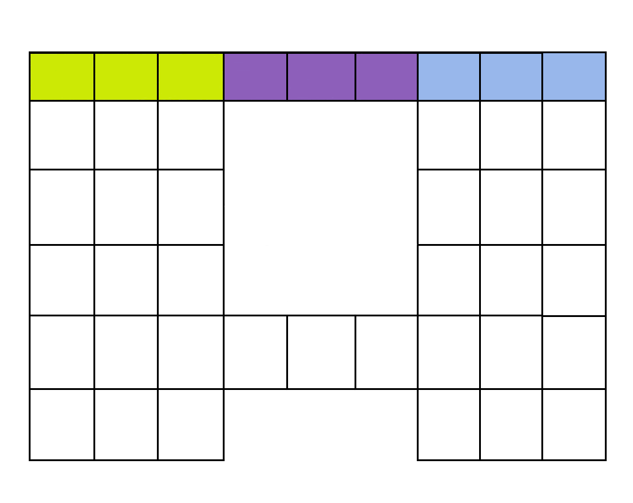

OPTION2: 9-DAY WEEK, 4-WEEK PER MONTH ALMANAC
A 4-day work week, a 9-day week, 10 x 36-day months and 5 intercalaries (days added to align almanac and solar years), a 5- to 6-day holiday or “short week” once a year. This gives 5 days per 9-day week for family and passionate pursuits.... much more relaxed.

The “swing” day is coloured green below to facilitate overlapping of schedules for activities such as worker shifts and days off.

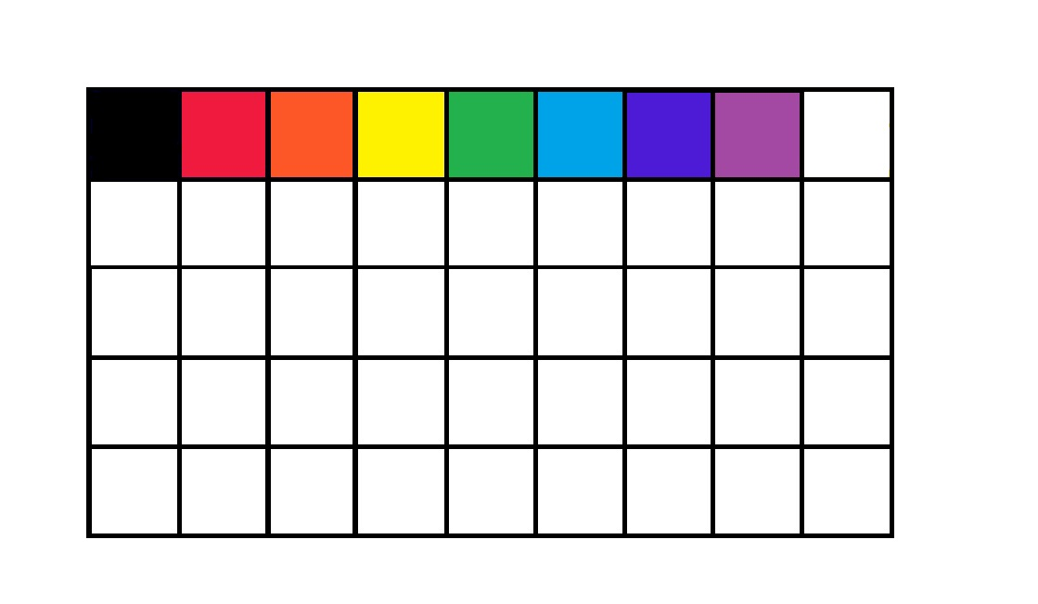
The 5- to 6-day “extra week” could be put in just before the spring “start” of the year, perhaps with its own page in the almanac and descriptions of ancient celebrations or other information included there.
Given that spring is the traditional start of the year, and the period of renewed growth when Nature “wakes up,” the almanac would be completely different from the current way of designating time segments.
The months could also be colour-coded, perhaps in reverse (white first, violet, purple, blue, green, yellow, red, black) with brown or grey as the colour of the 10th month, just before spring.
Names of weekdays and months can be altered to reinforce the new system.
[All suggestions are welcome.]
Weekdays options: Sagesday, Rtaday, Vedasday, Santiesday, Runesday, Keepersday
Perunday (messenger), Taraday ( ), Heimdalday (Aesir guardian of Asgaard), Sifday (harvest bounty), Thorday ( ), Freyjaday (love and fertility)
Months options:
Prana, Grail, Trinity, Yarila, Prav, Yav, Anuhazi, Cerez, Inyu, Azurite, Oraphim, Indigo
Courage, Discipline, Perseverance, Industriousness, Self-reliance, Fidelity, Honesty, Integrity, Respect, Compassion, Generosity, Love
Extra Days: Kinsday, Heartday, Soulday (summer solstice); (winter solstice) Enlightenment, Progression, Ascension (every 4 years)
Alternate: Energy, Frequency, Vibration
In ancient times, people had a different measure, called Year-Circle. Calculation of time was done not with centuries [100 years], but with Circles [16 years] and Circles of Life [144 years].This is due to the fact that hexadecimal numeration was used, not decimal. (From Santies)
https://ariowie.com/slawianski-zegar/ Slavic Time information

ZODIAC with Ophiuchus added
13 zodiacs x 28 = 364 with extra day in Pisces as the "year-reset" day.
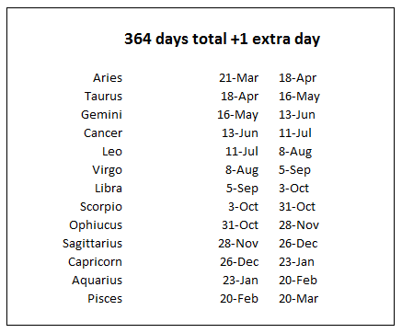
364 days total + 2 extra days:
The 7-day week times 52 weeks per year shortchanges us when compared with the number of days per month: 31+28/29+31+30+31+30+31+31+30+31+30+31 = 365/366
The shekel people stealing a day’s pay every year?

TIME-OF-DAY OPTIONS
1. Maintain old system of time: 1440 minutes per day, 24 hours per day, day divided into 8-hour segments of 480 minutes, leaving 960 minutes for sleep and other activities. (Or 8+1 hours for overlap in work shifts, leaving 900 minutes.)
2. Chance to 16-hour days, (a Slavic hour is 1 1/2 of current-time hours; i.e. 90 minutes). This would require altering clocks and watches. Work shifts could be 5 new-hour segments of 450 minutes, leaving 990 minutes for sleep and other activities, or a 4-segment shift of 360 minutes, leaving 1080 minutes for sleep and other activities.
[We would need a new name for this longer “hour,” such as temp (Latin), hora (Greek), slava (in deference to Slavic influence). All suggestions are welcome.]
A 4-segment shift (or 5 with overlap) would require scheduling of work shifts such that all business would require 2 shifts for daytime, 2 shifts for night if applicable, necessitating high employment.
With each shift worker requiring an actual living wage, and inflation banned, commerce would soon be reduced to production of goods and provision of services that are actually needed. (No more selling of real estate on Mars.) The deficiencies of monetary systems would also become clear quickly. Barter and other alternatives, which would not be taxed, would become more attractive, as would self-sufficiency of individuals and communities.

Recap:
Ground-up grassroots governance, with basic law unchangeable (Universal Law and True Rule of Law) and with practical rules across the country and with other customs made locally and regionally. Everyone can partake of governing. All regulations must benefit all inhabitants, not “majority” or select groups to the detriment of individuals and families. Individuals and families can opt out of customs but no one can change or opt out of Universal Law and True Rule of Law. Any opting out requires flexibility and cooperation and respect for others so as not to cause problems in the community. For example, all driving on the right side of the road, pedestrians not disrupting traffic, no littering.
True Rule of Law needs true public courts, not BAR guild private courts pretending to be public courts. It also requires local, old-fashioned Sheriff departments, the members of which live in the community, not corporate policy officers with no allegiance to or affinity for the community and its members, no knowledge of actual law, and a bullying mindset and training focus.
Community inhabitants need to watch out for each other and help each other. This can be encouraged by various programs, including organized Neighborhood Watch groups and training, volunteer fire department, and by a true (not Chinese-style) social credit system as described below.

Financial system no longer run by the Federal Reserve and the corporate banks. Instead, communities have their own banks under the authority and supervision of the local Congress Treasury Committee and a local or regional or country currency. Money is put into an account for each individual at birth, on reaching adulthood, and perhaps at other specific times in life—and the currency is controlled by the individual (or his/her parents or guardians until he/she has learned to use it responsibly), not by “the state” or by any corporation as in the old Federal Reserve system. While there may be some computerization, cash remains a primary means of monetary exchange.
An international currency is accepted everywhere, at face value with all local/regional/country currencies. Money of every kind has a fixed value that may not be inflated.
And/or, all currencies could be accepted at face numerical value everywhere, easing transition at start-up as communities and countries create their own currencies or adopt common ones by agreement.
Opinion:
The whole planet would have to be using the same set of increments to facilitate this. The list of permanently set values for specific items/services would be tricky because the same item will carry greater or lesser value (wanted more or wanted less) from region to region. To make prices more standardized, something that would have to go is the notion and desire for huge salary disparities and salaries being used as bait/incentives. That requires personal choice and personal ethics to be put in place concurrent to these monetary system changes.
The permanently set items internationally would likely be minerals, oil, and products like iron, steel, copper, brass, bronze. The prices of other items like foodstuffs would have to be agreed locally or regionally, perhaps, and would be contingent on what is available nearby. We as a people need to be more self-sufficient and not rely on imports and exports. Our economies need to be focused more locally for all basic needs, at least. Metals and products based on metals and oil would be "extras."
This is exactly what bulk commodities trading needs: more localization and a simplified process. The resources of a region going to produce goods for that region will be a big collective relief for all communities worldwide.
A credit system could be implemented as well, one that pays specified amounts to all who participate in activities of benefit to the community as a whole (such as attending meetings of Congress or Emergency Preparedness events or clean-up days) or of benefit to individuals or groups (such as aiding invalids or visiting with elders or teaching children useful skills). This cash cannot be taken away by any bank or governing body.
Barter and time-share are allowed and encouraged.
The primary tax is a fixed land tax that does not increase. Punitive taxes to discourage pollution and other harmful practices may be considered. Small-percentage tax to pay for function of regional, state/province, country administrative bodies may or may not be required.
People may join an Assurance (not insurance) fund, like a pooled savings account, to cover healthcare or other specified expenses in times of need. This would not include anything similar to liability insurance and car insurance because these tend to make people careless. Also, vehicle/travel rules need to make those who cause accidents accountable and to make it clear that no one has right of way on approach to any vehicle or pedestrian. (In places where the only rules are (a) you have a right to be in the space you are in and (b) no one has right of way on approach, there are few if any accidents despite lack of “safety” rules of any kind, including speed limits, which would be recommendations only.)

Work is self-employment or partnership in a business run by two or more people, and both individuals and groups/companies can advertise services or needs for free or for a token sum on a community website and/or a community bulletin board. People able to work are encouraged by the fact that they increase their income and are able to do what they are good at/enjoy doing.
Self-sufficiency as individuals, families, and communities requires moving away from dependence on products, services, and resources outside the community or region. Self-reliance on individual and community and regional levels promotes sovereignty and, ultimately, prosperity.
Local reliance for the basics of survival (food, water, shelter, appropriate clothing, energy especially for heating and cooking) is essential. Each household as well as local businesses and cooperative groups and even school children can contribute, including by growing food instead of lawns, making cloth and paper products, growing fiber crops and fuel crops, and using local materials for homes and household products. Making tools locally to the extent possible is also advantageous (many can be made of wood instead of metal).
Local fashion can be encouraged, using locally crafted fabrics and yarns and dyes, in designs created by community members.
Home building can be individual DIY projects or community projects like old-fashioned house and barn raisings. Land cannot be owned per se, as all land and resources belong to all of us, but Title can recorded by a committee of the local Congress and thus right of use is given to the Title holder. (Individuals or families can hold Title, not companies of any kind, and not governments or other organizations.)
Farming and local transport can rely to a large extent on animal power (including simply walking). This would provide valuable manure for soil improvement as well as not requiring oil-based fuels or a lot of expensive and non-local metal machinery.
Electricity can continue to be available through free-energy technologies that require wire but not dams, wind farms, solar panels, nuclear plants, or other technologies primarily under control of corporations. Aether energy is free except for the wire needed and, in some designs, mercury. Magnetic energy is also relatively inexpensive and benign.
The metals for these and for electronics, as well as “clean” oil products, are the primary items that would continue to require resources and manufacture that would more likely be regional or continental than local. This type of technology would continue to facilitate communications, long-distance transport, and other needs (including manufacture of such products as bicycles and tricycles, copper and brass garden and kitchen wares, and computers.)
The need for production and distribution of products such as metals, metal tools, and refined oil would necessitate regional and continental exchange. This is best done primarily by barter of commodities rather than using currency.

Health care starts at home, with healthful food, sunshine, exercise, clean water, adequate shelter and clothing and heating, and an understanding of our bodies and how they actually work. Knowledge of first aid is another requirement for a healthy society. Health care workers must be trained adequately, and health care workers and facilities need to be held accountable. One way is a system in which they are paid only if the patient is healed of injury or cured of illness and kept healthy. Poisons and invasive tests and treatments must be banned.

Learning is a lifelong activity and community members are encouraged to learn as many skills and as many different kinds of skills as they are able, from practical capabilities including gardening and animal husbandry and cooking to first aid, wilderness survival, and plant identification to music and dancing to other languages and more.

Community harmony is best facilitated by encouraging people to know each other, to interact in pleasurable ways, and to help each other. To this end, communities can explore such options as seasonal celebrations, regular dances, old-fashioned activities along the lines of house raisings and canning parties, street pot lucks, and other interactions that bring neighbors together. Elders and children must be honored, and this needs to be expressed clearly, perhaps through special time-of-life ceremonies and celebrations. Ceremonies to honor the Divine Masculine and Divine Feminine, the male and female, can heal the politically motivated gender confusion that has arisen, as well as the longstanding culturally promoted antagonism between men and women and the equally pervasive and harmful rivalry and competition among men and among women.

