Dear Media Team,
Please help me figure out how to delete or change the settings for the offensive photo stream in the lower right-hand corner. All my low-techi efforts just make it enlarge to full screen.
I would also like to lodge a complaint with MeWe for unsolicited offensive content in a private group forum. And why is X-rated content allowed? Freedom of Speech okay, but not visual content thank.you.very.much.MeWe.
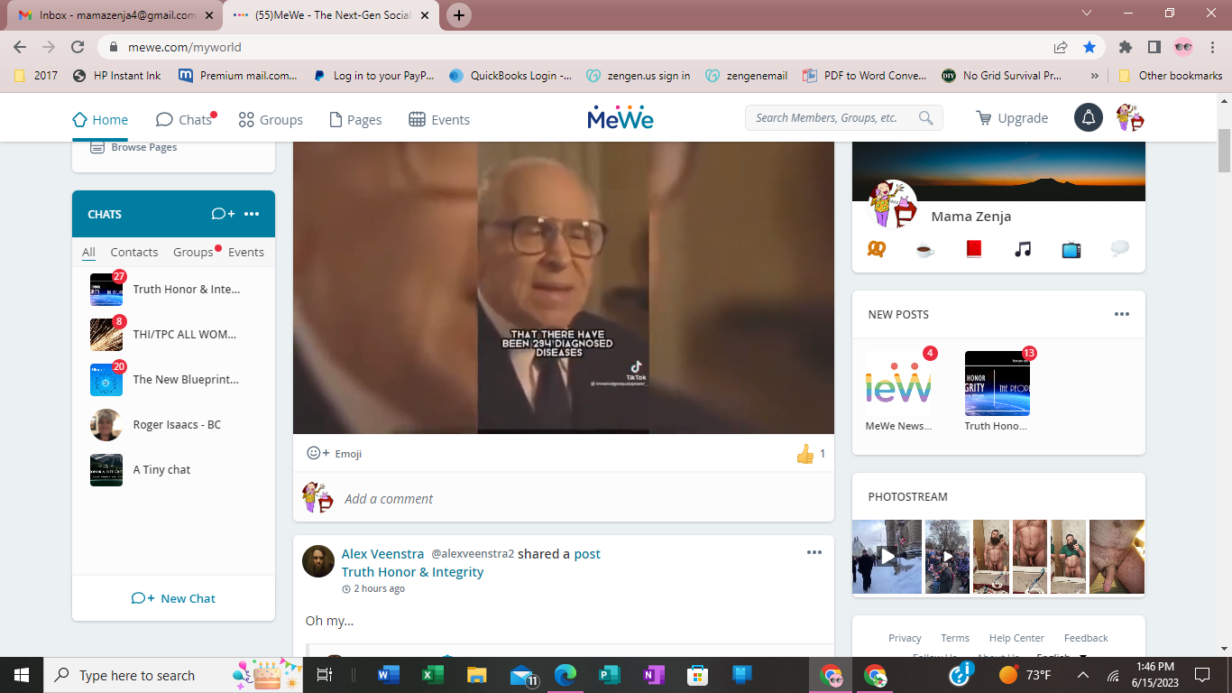

Thank you!
Mama Z (Debbi White
MeWe profile: @mamazenja
Email: mamazenja4@gmail.com

