Asgard Spiritual School
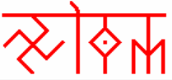

Yujism or Yugism (Міровоспріѧтіє) - The Perception of the World

The 9 Chakra System. Time (ВРѢМѦ)

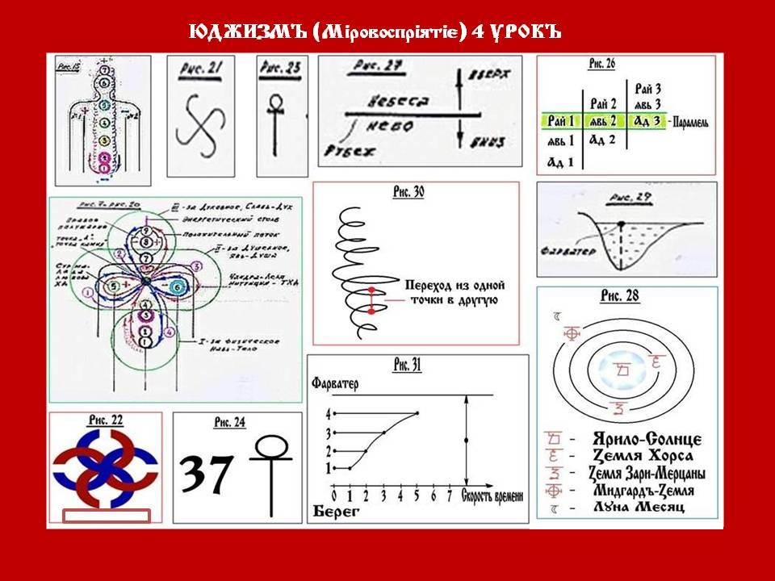

Now we’ll take a careful look at the drawn man with seven chakras (Fig 15). But this generally the Eastern But this system is taken from the Slavѧnj (Slavs). Therefore in Northern India, even though everyone refers to the Mahabharata as an ancient knowledge, but it is in the Northern India, in certain ashrams (temples) the priests (as they are called them, the great gurus) do not use the general Eastern system of seven, but our nine 9 system. For them nine 9 is like a higher system. They add two more chakras: (Fig. 20 = Fig. 7) - in the armpit area on the diagram. As a result, they have a nine-chakra system. But what do they call it? As an addition: one - SURMA chakra - is the solar breath, and the second - CHANDRA chakra - is the lunar breath. And these - solar and lunar chakra they call chakras that responsible for the connection with the Ancestors. In this way the nine chakras are preented.
And notice that we have drawn an energy column with you (pic 15). If the solar chakra is with a plus sign and the lunar chakra with a minus sign, there should be such a ratio throughout the energy column - alternation of the plus and the minus. But here on the diagram on the right side of the head there is a plus and on the left side there is a minus. And even our visual nerves are switched from the left eye to the right hemisphere and from the right eye to the left hemisphere in order to perceive normally. That's why there is no such flow as in the energy pillar. There is a completely different flow here. On the diagram(Fig 7, 20) it is drawn not as a spira, l but with a simple (red) line to make it clearer: it goes from the bottom to the top, then around the chandra chakra, then in a small circle around the surma chakra, and up to the head. This is how the positive flow moves. It is in red colour.
And from above, another stream flows down from the head, and again through this point "A", in a small circle around the chandra chakra, passes to the big circle around the surma chakra, and goes down through the point "A", where everything unfolded. Someone considers this point "A" to be the point of harmony, someone considers it to be the point of balance, someone considers it to be Krishnaloka, i.e. a special place where all paths converge.
That's why if we take the Bible, and it is also related to Eastern systems (Middle East), Jesus said to his disciples: Everyone carries his own cross. And this is not a wooden cross on his shoulder, but his own energetic cross (see Fig. 20), where everything is in motion
In lilac colours you could see four stream , a roraring cross in Fig. 21. And if they are connected it with the opposite stream, as if to impose two swastikas, we will receive the ancient Slavonic symbol, which is called - the Wedding Man (Свадебник) (Fig. 22). It is a connection of male fire with female waters, i.e. male and female joined in one.
So, in the eastern system everything is built on seven, and only at some, let's say, more enlightened priests there is a nine-chakra system. Everything should be learnt in comparison.
THE SLAVIC SYSTEM (СЛАВѦНСКАЯ СИСТЕМА).
The Slavic energy centres system is more expanded than the Eastern system of chakras.
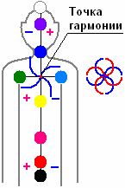
It contains 37 main energy centres, where 9 nine are dominant and 28 are defining, all together they create an energetic cross. Moreover, the dominant centres are divided into three structures: the first lower three chakras are responsible for human development (physical, manifest). The middle ones are responsible for the Soul development and the upper three are responsible for the Spiritual development. In the diagram (Fig. 20) we would still put three circles, combining three chakras each.
The nine dominant Slavic chakras:
- ИСТОК, pronounsed [IS’TOK] (meaning SOURCE) – is located in the area of the coccyx. The very concept of Istok says that the energy of a person's life begins to flow from here.
The colour is black. It comes from the depths where light has not yet been born, but life has already begun to form. Therefore, the colour is black, and at the same time black means unexplored, beyond the limits of human perception. In the sound range this chakra does not work on the note "Do, La or Si” , this chakra perceives infrasound, infrasonic vibrations. INFRA means - very low. That's why pilots are forbidden to enter thunderclouds, because the frequency and amplitude of 5-7 Hz operates there. This can put the brain into resonance and a person can die. There is the so-called voice of the sea. When the ships meet, so-called flying Dutchmen, the coffee in the coffee machine is boiling, everything is set on the table, but nobody is there. And then scientists found out that there is such a concept as infrasound, it is also called the voice of the sea, it spreads on the surface of the seas and oceans at an average speed of 700-800 kilometres per hour. When this infrasound wave comes, a person has a terrible fear, he starts to run anywhere and - overboard. And this is it. That’s why it is said - the ships met, but no one is there.
In the 70-80's there was an article in a newspaper that a rock band decided to use a synthesiser with infrasound sounds and pipes for mystical compositions during a performance in a music hall to make the atmosphere more scary. So the crowd took the doors out, they broke them down and tore them apart. And all because of the low infrasound frequencies on a synthesiser, on an organ was palyed, there was a feeling of wild fear.
If a person is afraid of something, it was as if someone has nailed him to the ground, to the floor, and he cannot not move, and why? Because this initial source brakes the whole system, and the person, like a computer, is frozen.
- ЗАРОД, pronounsed [ZA’ROD], meaning FOR THE KIN – is located in the pubic area. The word in Russian means “for the Kin” hence this chakra is responsible for the Kin, for the birth of life. The colour is red and the sound is "DO".
- ЖИВОТ, ronounsed [JI’VOD] meaning LIFE in ancient Slavic, in modernday Russian it meaning Stomack – its centre is the navel itself. That's why even samurai, when they wanted to end their life, they do harakiri - they cut their stomach open.
And think about the expression "the stomach hurts", it means life hurts. "Stomach ache" means life ache. The sound is "RE." Through the umbilical cord, the life force flows from mother to child. Cut the umbilical cord, it's from Nature. So where does life begin? In the womb of the mother. Our first chakra is black, second - red, third - scarlet. The colour is scarlet. The Slavs have their own colours.
- ПЕРСИ, pronounsed [PER’SI] PERSI means CHEST in Slavonic. It is not one or two breasts, it is the whole chest. And its centre is the solar plexus. If you pronounce: Reeeee (Рээээээ). Where does the RE spreads? In the stomack. Each sound corresponds to the chakra location. In our (Slavic) system, we have frequencies that correspond to our organism: in the solar plexus this is the sound MI and the colour is golden. Not yellow, but gold.
Percy this is the creative energy and creativity.
- ЛАДА, pronounsed [’LADA] – responsible for Love. Colour green. Why? Nature gives birth and reproduces, but reproduces with love. Right sholder, sound FA.
- ЛЕЛЯ, pronounced [‘LELIJA] – left sholder, sound SOL. It is responsible for the intuition. Lelija was also one of the three Moons of Midgard, where was it? In heaven, that’s why the colour is heavenly.
- УСТА, pronounced [‘USTA], meaning MOUTH – or as they called it in the West, Justa. Hence Justice, i.e. the mouth proclaims the rule. Twe have Istok (Source), and we have Usta (Mouth).
It embraces the throat system, the colour is blue, the sound is LA. And notice, opera singers, before they go on stage, what they must they do? They have to warm up their vocal throat system. And they go backstage and they sing: la la la la. Put two fingers on your throat and say: la la la la. Feel the vibrations go where?
- ЧЕЛО, pronounsed [CHE’LO]– meaning FOREHEAD is between the eyebrows, hence: The forehead. But this place is wrongly called lobe. The lobe is on top of his head, top of the heal so to say, from here comes the phrase headland or lying area – this is the place on the toppo of the hill where people were killed (as a dead sentence). The sound is SI. The colour is marny (violet), where there is a special radiance which is not red, not blue, but with a violet. There is a special workin Russian called Marevo. This chakra processes and reworks images and thoughts.
- РОДНИК, pronounced [ROD’NIK] – but our parents still call this chakra by a diminutive - weasel word - RODNITCHOK. It's a connection to Rod (the KIN). And Rod (Kin) in all its purity is the colour white. And sound is not perceived by human hearing, it igoes beyond it, it will be ultrasound. That's why when you have a headache or something needs to be done to your head, people go to the hospital for ultrasound.
We have recorded 9 main chakras, but there are 28 intermediate chakras. All together there are 37, they create an energetic cross. The river starts at the Source and ends at the Mouth. Here we have the source - chakra 1 and here we have the Mouth - chakra 7, and what ends in the Mouth? The spine, because the skull comes next. In this system our Ancestors reflected the internal energetic structure of a human being, shown in (Fig.25) an energetic cross (the Tau cross), where the spine ends and the skull begins. In ancient times this TAU cross symbolised the man standing with his arms spread wide spread - embracing the world. Recall the Queen of Spades: three, seven, ace. Trinity, semericity, transcendence (Fig.24):
As long as a person is at the level of trinity (three lower chakras), he lives by his instincts. When he connects to the Soul - the level of semericity (4th, 5th, 6th chakras), he starts to develop. But what is that? You have to feel it. You have to feel colour you have to feel to write music. That's why the Eastern system of 7th chakra, disperse the energy from the 1st chakra along the spine, from the Source to the Mouth, all the energy is released through the 7th chakra in the form of the sound, murmuring OM, i.e. in the form of mantras: OMMMMMMMMMMMMMM, or AUMMMMMMMMMMM, or Amen, Amennnnnn, And everything ends at this level - the levels of the 7th chakra. And only the Slavs go further.
Let's return to the Queen of Spades: while Herman was living with these lower chakras 1,2,3, i.e. earthly interests, did the three fall out? It/he did. But he went to social balls, music, painting, etc. - Did he get a seven? He did. And when it touched the ace - the transcendent, i.e. the highest, Herman could not realise it, because the trinity was too much of a drag. That's why he got the turn around. Where the arrow goes? Like in the a spade - "Come back down. And he fell down. Who told him this? An old witch, like he said? And the old witch is the Vedic Mother (Вѣдающая Мать). But she's still, in Latin, a lady (DAMA/Дама). She said: You'll win if you achieve transcendence. Then you'll have it. That is, not as an end in itself - a three, a seven, an ace - but as a way of knowing. You've forgotten what the point is. And here are the images for you.
Very often correlations happen. Take the same Mr Barashkov, aka Ace, aka God Kryshen, aka Prince Yogailo and other pseudonyms. He compares, as well as the academician Rybakov, the Slavonic Triglav with the Christian Trinity, why? There are three in each of them. But they confuse Veles with Vlasius, etc. The Slavs never had a trinity, the Slavs had svasticity. This we will understand later. And notice, the confusion is also because they have what? This is consonant, so this is similar. Nothing of the kind. Let's assume that this (Fig.26) is not identity, these are the entrances, let's assume that this is Hell 1 (Fig 1 , column 1 Ад 1), above it is Yavi 1 (Явь 1), and above it is Paradise 1 (Рай 1). Let’s take the philosophy common to East and West: Hell, Yav, i.e. our manifest world, and Paradise (Eden). But notice, for some, Yav 1 is Hell, and Paradise 1 is to them like Yav 2. God for them lives even higher, but for some people Yav 2 is Hell 3, i.e. the lower world, and Paradise 2 is their Yav 3, and they have Paradise even higher, see? I didn't say about the symbol of trinity for nothing. And now look: Paradise 1 is like a water parallel with Yav 2 and Hell 3 (Paralel/Паралель).
There is such a Slavonic saying: "If you live a righteous life, you will find the Pure Svarga. And if you live an unrighteous life, you will go to the Christian paradise".
Notice, what is Paradise for Christians is Hell for us, we say, Peklo (Burning). And it is the same structure that exists explicitly.
There is such a thing as a connection of opposites. For example: Light - Darkness (Darkness is ten thousand in Slavonic), so there are Worlds of Darkness and there are Worlds of Light. And our Ancestors separated them. Everything that belongs to the Light, they called NEBESA (НЕБЕСА), meaning Heaven, or SVARGA. And that which belongs to the World of Darkness they called Sky (НЕБО). And notice, Heaven (НЕБЕСА) is where there are no Demons (Нет Беса). And Sky (НЕБО) is where there is no God (Нет Бога). In Christianity: there are Angel of the first Sky, Angel of the second Sky, and so on up to the Angel of the seventh Sky. It is said of Jesus that he went to the Seventh Sky. We say: 16 Abodes of Svarga or 16 harmonious Heavens, not counting the intermediate ones. I.e. our system of Heaven goes upwards from the boundary, and the system of Skies goes downwards from the boundary. That is why these two systems do not overlap (Fig. 27).
That is why our language has been destroyed, so that people do not know the difference between Sky and Heaven (Небом и Небесами). Lunacharsky, by his Decree of 10.10.1918, removed the prefix BEZ (meaning WITHOUT) and instead introduced BES (meaning DEMON), i. e. a man himself, without knowing it, started demonizing it. For example, a gloryless end (безславный), i.e. without glory, and if instead of BEZ to use BES, it turns out that a person constantly calls a demon and glorifies it. And we always had BEZ [this is Russian languange. In Bulgarian we still have this BEZ form].
And the most important thing was to awaken God in man, the descendant of Gods.
Everyone has his own. They have their own. Ask a clergyman what he knows in detail about the life after death? And the representative of each religion, in a confession form will tell about in details about the world he serves. For example, Christian bishops often say: It's all from Satan, it's from the devil, you will go to hell. And they describe it in every detail. Faith or faithconfession (Вѣра или вѣроисповедание) should not be built on fear. Ah, and if you don't accept it, you'll get this, this and that. How do you know? Have you been there already?
So if there are differences between Light and Darkness, and differences between Heaven and Sky (Небесами и Небом), then the systems are not the same, but they may be similar in structure. And besides this, for each one of us things happen differently. And what is responsible for the difference in happenings to us? TIME is responsible. Each of us lives in our own time.

Theme: TIME (ВРѢМѦ) (the third and the last letter Ѧ should be written in Slavonic).
You should understand that Time (Врѣмѧ) is different in the World of Yavī. Time is both objective and subjective, there is external time, there is internal time, there is the concept of no time (безврѣменья), there is the concept of compressed time, i.e. there are many different concepts of time.
Many consider the fourth dimension as Time. And there are various systems that not Space and Dimensions create Time, but Dimensions and Spaces derive from Time, i.e. the combustion of Time generates them.
There is such a concept as the River of Time, let's consider the scheme (Fig. 28) - here is the Yarilo Sun (Ѧрило — Солнышко). The Hors Earth (Mercury in Roman or Hermes in Greek) turnes around it. It revolves around the Sun for 88 Earth days (our time), periodicity, but it has its own time. The time there is completely different. The second planet that turns around the Sun is the Earth of the Dawn of Merzana (Venus, in Roman). The third is our Midgard - the Earth with one moon, although there used to be three. Now notice, the further the light is from the source, the spectrum changes: from ultraviolet - white it goes to red. The same is the time from the source: Hors will have one time, Mertsana will have another time, Midgard will have a third time. Why? Because the Earths rotate with their own rotation frequency. I.e. the Earths have their own swinging frequency - they move in space. Let's talk about the influence of other Earths, for example, on Hors. The oscillation is the distance from the circular orbit, i.e. these changes themselves were called change in time.
But this also applies to every human being. Now they're introducing winter and summer time every year. They seem to save electricity. But at the same time, changing the time by an hour breaks people's psyche.
Another event may seem fantastic to many people, but it was reported by all the media of the world in the early 90s. All the noise was connected with a spaceship that had crash-landed in the Atlantic. It was picked up by the American Coast Guard. No one would be surprised, because Americans fly, but it turned out that it was not Americans, but Germans. And it seems that nothing was officially announced anywhere in the media about the launches of the FRG. In the process of investigation it turned out the following: the spacecraft with three astronauts on board was launched in the north of National Socialist Germany in 1943, as it was then said with the blessing of the President and Reich Chancellor Adolf Iloizovich Hitler. And they flew from '43 and spent 47 years in the air. And in '90 they landed. They didn't age at all. And they were immediately asked: how is it, where did they fly, what did they do? And they even had a telegram from "daddy" Hitler.
Very much is written in newspapers now about the so-called German saucers, which were in 43-45th years, and then they defeated the American fleet near Antarctica. There is "New Schwabia", "New Berlin" and so on, but that is not the point, the point is quite different, the point is that everywhere there is a message that time changes.
They show our (Russian) pilots fighting with Israeli pilots on the side of the Egyptian Air Force during the Suez crisis. And during the battle, our pilot, pinned down by the enemy, found himself over the Egyptian pyramids, many kilometres away from the battle site. The aeroplane was intact, and there was not a single scratch. And this happened to many pilots. Remember, we have already analysed that pyramids are volumetric-temporal devices, and time flows in them in a completely different way. And if it flows differently, it means that it also changes the temporal structures around it.
Everyone has heard about the "curse of the pyramids". The press described that people who went inside the pyramids died very quickly one after another. It was explained by the curse of the pharaohs, that it was not good to enter the pyramids. Because these imposed curses kill all who get there. But among the messages about the dead, in this nightmare, there are other messages, on 5-7-12 pages, which were as if unnoticed, that from those who first entered the pyramids, let's say, 20 people entered, three got rid of all diseases and became younger, and 17 died. They explain their deliverance from diseases by the fact that these same people were treated with pills, etc., they were treated!? But notice that 17 people died within a year, and these three lived for a very, very long time. Rarely did anyone pay attention to this and rarely did anyone connect it with the pyramid. And what happened? Entering the pyramid, into this time converter, someone's life flows went to compression and someone's to expansion. And the person whose flows were compressed, he left the pyramid, and he started to live, let's say, 10-15 years per day. I.e. his life eventually burned out quickly. And those who had life flows stretched, their organism recovered, although it is very difficult to recover in a stressful society, but they were healed and lived unusually long afterwards. And these people understood that the ancient Gods gave them a chance.
And notice, all the nations that exist, they all talk about the River of Time (Реке Врѣмени). And what kind of a river do we have? If we take it in section, then usually one bank is steep and the other is gentle-rolling (Fig.29). And notice where the greatest speed of the river will be? Here at the point called the fairway, here is the maximum speed of flow - it is like the River of Time in section. And it should be represented not just as a river, but as a river spiralling and rising upwards. But it is not an even spiral, but it is a spiral that increases somewhere and decreases somewhere.
Then it increases again and decreases again (Fig 30, the text – transions from one point to another).
And as if transitions from one point of one turn of the spiral to another point of another turn they are in principle permissible (Fig. 30). For this purpose it is just necessary to know the transitions, where and when it is possible to cross - one line is the fairway line, the second line is the shore line. Each person he is at a different distance from the shore. And where the water is running slower? At the shore. And where does it run faster? On the fairway. And everyone is at his own point of distance from the shore and from the fairway. Therefore, if a person has left it, he will not enter his own path. That is why they say: "You cannot enter the same water twice". Because even the molecules that were next to each other, the difference of the current tears them apart and they fly in different directions. So you cannot enter the same river twice.
Let's review. Here is the zero reference point (Fig. 31), and 1 is a turtle, 2 is a man, 3 is a dog, 4 is a mosquito. After some definite interval of time, let's put intervals on the axis of Velocity of Time - they are not years, not centuries, they are definite segments. For a turtle, one interval has passed. For a man, two intervals have already passed. For a dog, three intervals have already passed, and for a mosquito, let's say, five. What do we have? We have this graph-line. If one more segment passes for a turtle, then for a human it will be 4 segments for a dog - 6, for a mosquito - 10. And so on it will increase. Therefore, notice, everyone lives a certain life. Well, let's take a life roughly, let's say 150 years. Just for a human 150 years for a mosquito, and he is closer to the fairway, they can be in a day, two days. But for a mosquito it will be his 150 years. And 300-400 years of life of a turtle, which is just closer to the shore, so it lives its 150 years, but for us it is like 400.
So every creature has its own age. People try to advance in time. For them it seems that time flows parallel to their time and they even create devices that supposedly measure their way. Everyone needs to know HIS time, to take care of it.
It seems to be one structure. But there is the concept of internal time, and there is the concept of external time. And these forms of time are different. Imagine two thousand-year-old oak trees, they communicate with each other.
And the oak tree on (Fig.3) is almost by the shore. The oaks have millennia, and we have centuries, i.e., time is as if stretched tens of times. And imagine what would happen when a man came, cut down and took away one of the oaks that were communicating with each other? For the second oak tree it will seem a strange, inexplicable miracle - its interlocutor has disappeared, he had just been there, and suddenly he disappeared, some metamorphosis has occurred. Why? Because time is different. That is why man does not notice not only the time of others, but he does not even notice his own time.
Jules Verne's book, Around the World in 80 Days. There two heroes travelled to the East, betting that they would circumnavigate the globe in 80 days and return to London. And they did get back to London, but it turned out that they themselves had travelled 80 days and the Londoners only 79 days. The travellers had sort of wasted one day of their lives. They had lived one day longer. Because according to their wristwatch it was already Sunday, but in fact it was only Saturday. Although according to their watches they passec exactly 24 hours.
Or, it takes three months to walk from Omsk to Moscow. Well, almost 3,000 versts. It takes three days by car. And by plane, three hours. And sometimes even less. And it turns out to be strange: you leave Omsk at 8 a.m. local time, and arrive in Moscow at 8.8 a.m. local time, i.e. you go back in time by 20 minutes. And at the same time, note that your organism accumulates internal time not 20 minutes or three hours of flight and 20 minutes, but three months of time accumulated inside you. It would be like walking to Moscow. But if you fly back by aeroplane, what happens? Not only do you spend these three months saved, you also spend an extra three months. So we will spend six months. So the body kind of recovers the time that you flew there and flew back. To do that, how long do you have to walk? Three months there and three months back. That's a six-month expense.
This is the end of our introduction to the initial form of time, and in the next lessons we will look at timeѧ in more detail.

